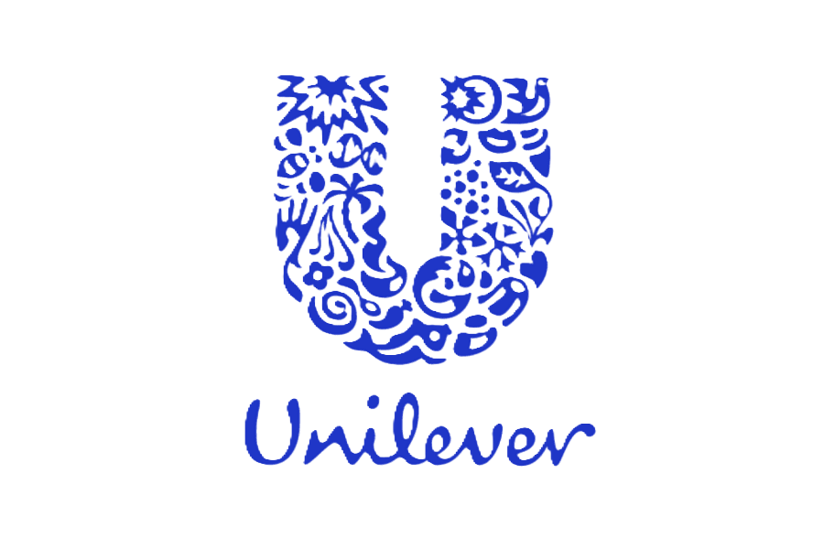

A Report About Unilever Consumer Care Limited

**Submitted To:**

Dr. Md. Manjur Ahmed

Associate Professor

Department of CSE

University of Barishal

**Submitted By:**

Name: MD. AL MARUF

Roll: 01-021-15

Batch No: 21

Date: September 29, 2024

# Index

|  |  |  |
| --- | --- | --- |
| S/L | Contents | Page |
| 1 | Executive Summery | 1 |
| 2 | Product and Services | 1-- 2 |
| 3 | Business Plan | 3--4 |
| 4 | Sales and Cost Statistics | 5--7 |

# Executive Summery:

**Unilever PLC** is a British [multinational](https://en.wikipedia.org/wiki/Multinational_corporation) [fast-moving consumer goods](https://en.wikipedia.org/wiki/Fast-moving_consumer_goods) company founded on 2 September 1929 following the [merger](https://en.wikipedia.org/wiki/Mergers_and_acquisitions) of British soap maker [Lever Brothers](https://en.wikipedia.org/wiki/Lever_Brothers) and Dutch margarine producer [Margarine Unie](https://en.wikipedia.org/wiki/Margarine_Unie). It is headquartered in [London](https://en.wikipedia.org/wiki/London), [England](https://en.wikipedia.org/wiki/England). The company's products include baby food, beauty products, bottled water, breakfast cereals, cleaning agents, [condiments](https://en.wikipedia.org/wiki/Condiment), [dairy products](https://en.wikipedia.org/wiki/Dairy_product), energy drinks, healthcare and hygiene products, [ice cream](https://en.wikipedia.org/wiki/Ice_cream), [instant coffee](https://en.wikipedia.org/wiki/Instant_coffee), [instant noodles](https://en.wikipedia.org/wiki/Instant_noodle), pet food, pharmaceuticals, soft drinks, tea, and toothpaste. It is the largest producer of soap in the world, and its products are available in over 190 countries. 3.4 billion people in 190 countries use Unilever brands every day. Bangladesh has a huge marketplace for consumer.

# Product and Services:

[Unilever PLC](https://www.unilever.com/) is a multinational consumer goods company that offers a wide range of products across various categories. Here are some of the main product categories they specialize in:

**Personal Care:** Soaps, shampoos, conditioners, body lotions, deodorants, shaving products, oral care products, and skin care products.

**Home Care:** Detergents, fabric softeners, dishwashing liquids, air fresheners, and cleaning products.

**Foods:** Ice cream, frozen foods, condiments, spreads, and cooking oils.

**Beverages:** Tea, coffee, and other beverages.

Some popular Unilever brands include:

**Personal Care:** Dove, Lux, Sunsilk, Axe, Vaseline, Pepsodent, Pond's

**Home Care:** OMO, Surf Excel, Vim, Domestos

**Foods:** Knorr, Hellmann's, Ben & Jerry's, Magnum

**Beverages:** Lipton, PG Tips

Unilever’s Some of the World most Product here I include-

# Business Plan:

Unilever have a long tradition of being a responsible and pioneering business. It goes back to the days of our founders, including William Lever, who launched one of the world’s first purposeful brands, Sunlight Soap, more than 100 years ago. And it is at the heart of how we run our company today. We strive to do better for our planet and our society – not just less harm. We want to act on the social and environmental issues facing the world and we want to enhance people’s lives with our innovative, sustainable and high-quality products. This is how we will grow our business.

* ***Strong Brand Portfolio***: Unilever has a portfolio of strong and trusted brands, including Dove, Lipton, Knorr, Hellmann’s, and Axe, among others. These brands have a high level of brand recognition and customer loyalty, which has helped Unilever to maintain its market share in various product categories.
* ***Global Presence***: Unilever operates in over 190 countries worldwide, which provides it with a significant advantage in terms of market reach and distribution. The company has a strong presence in emerging markets, which account for over 60% of its sales.
* ***Diversified Product Portfolio***: Unilever has a diversified product portfolio that spans across different categories, including food, beverages, cleaning agents, personal care, and beauty products. This diversification helps to mitigate risks and provides the company with multiple revenue streams.
* ***Sustainable Practices***: Unilever has made sustainability a core part of its business strategy, which has helped it to establish itself as a leader in sustainable practices in the consumer goods industry. The company has set ambitious goals to reduce its environmental impact and has been recognized for its efforts in this area.

## Product Details

We will demonstrate that our business model delivers consistent and competitive growth delivering financial results in the top third of our industry.

* We will build a consistently high growth portfolio
* We will win with our brands, powered by unmissable superiority
* We will accelerate growth in key markets and categories
* We will lead in key channels

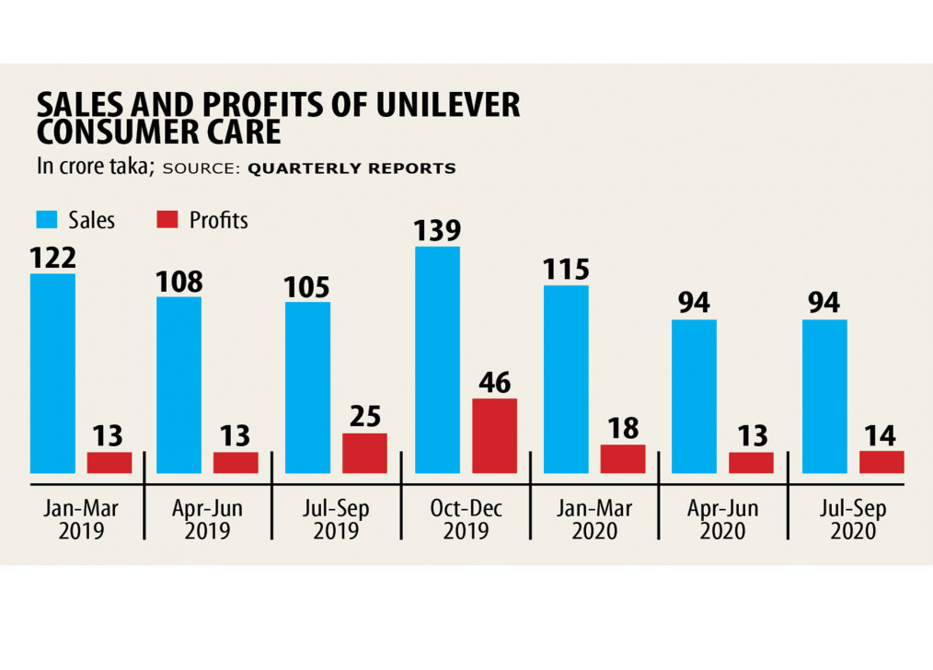

Most Sales of the [Unilever PLC](https://www.unilever.com/news/news-search/2024/whats-behind-unilevers-fullyear-results/) in the worldwide around 2019-2020

[What’s behind Unilever’s full-year result?](https://www.unilever.com/news/news-search/2024/whats-behind-unilevers-fullyear-results/)

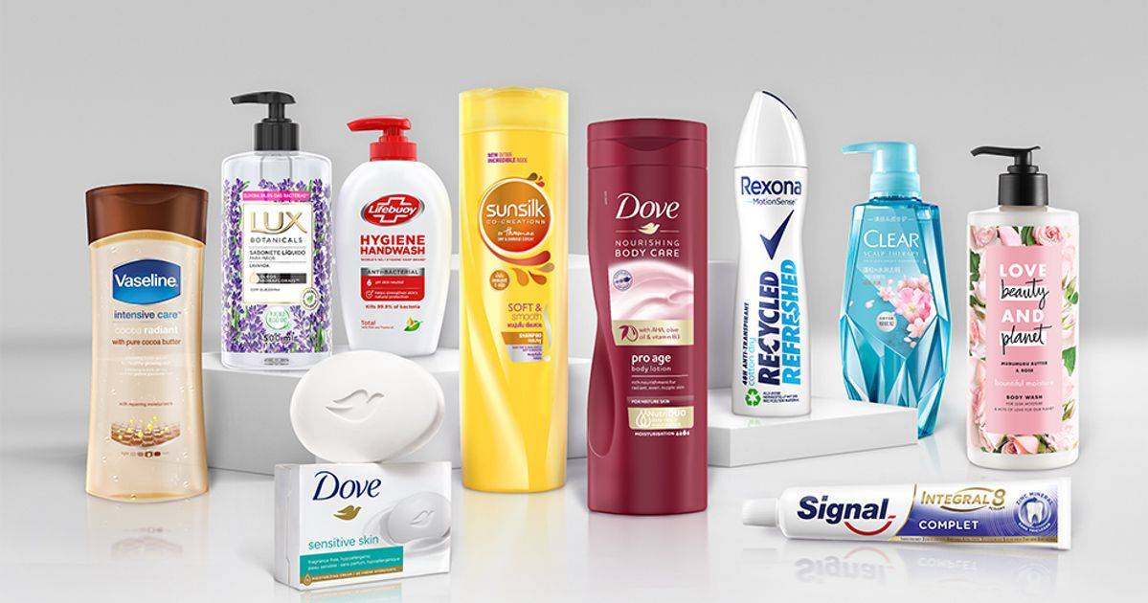

# How Unilever is shifting from a food to a personal care business

# Sales And Cost Statistics:

Unilever reported cost of goods sold of 36.882 B for the latest twelve months ending June 30, 2024 on its income statement.

The tables below summarize Unilever’s Cost of Goods Sold and common size over the last five years:

| **Fiscal Year** | **Cost of Goods Sold** | **Revenue** | **% Revenue** |
| --- | --- | --- | --- |
| 2019-12-31 | 32.644 B | 58.306 B | 56.0% |
| 2020-12-31 | 35.04 B | 61.964 B | 56.5% |
| 2021-12-31 | 34.44 B | 59.69 B | 57.7% |
| 2022-12-31 | 38.447 B | 64.325 B | 59.8% |
| 2023-12-31 | 38.009 B | 65.803 B | 57.8% |

The tables below summarize Unilever’s Cost of Goods Sold and common size over the last four quarters:

| **Quarter Ending** | **Cost of Goods Sold** | **Revenue** | **% Revenue** |
| --- | --- | --- | --- |
| 2023-09-30 | 18.199 B | 15.422 B | 118.0% |
| 2023-12-31 | 19.005 B | 16.105 B | 118.0% |
| 2024-03-31 | NA | 16.789 B | 0.0% |
| 2024-06-30 | NA | 16.667 B | 0.0% |

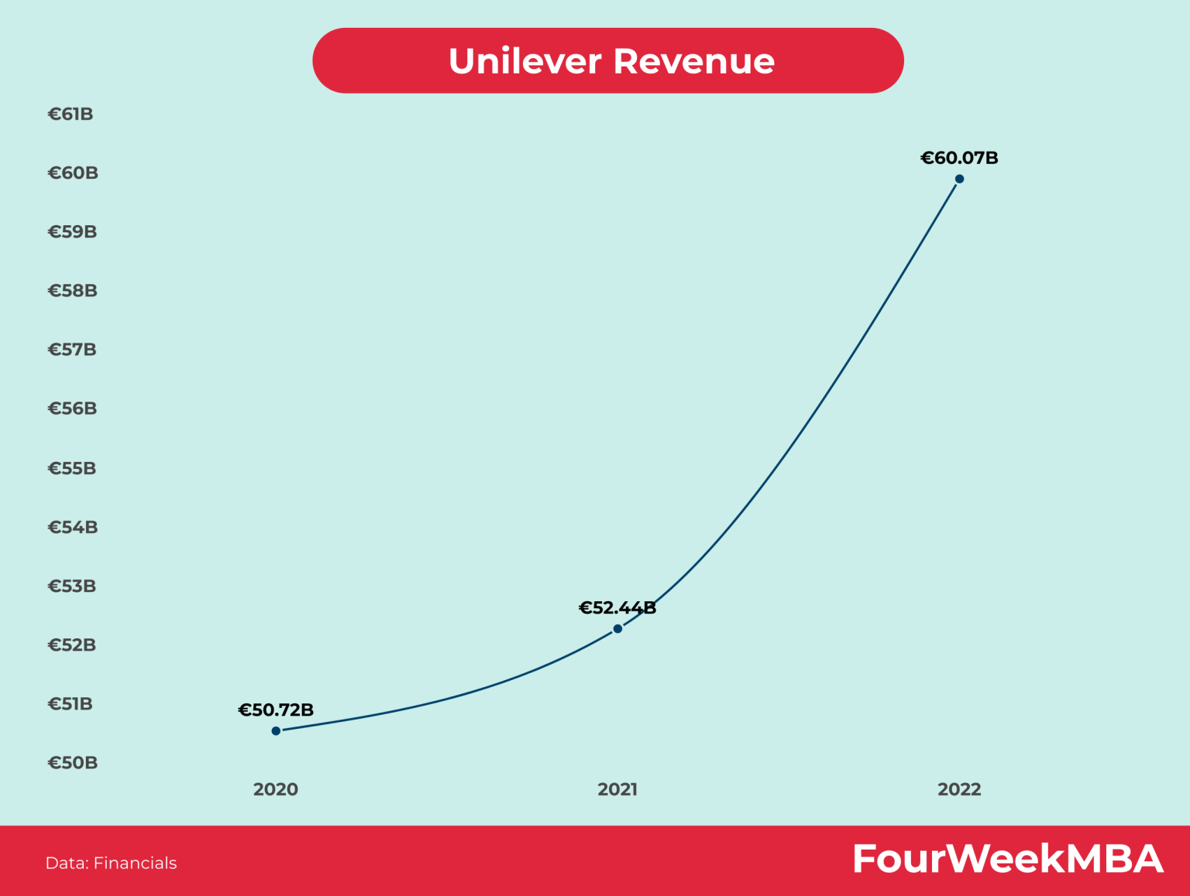

[**Unilever Consumer Care Limited**](https://www.unilever.com/news/news-search/2024/whats-behind-unilevers-fullyear-results/) is a leading Fast Moving Consumer Goods (FMCG) company in Bangladesh, renowned for its diverse range of health and hygiene products.

Operating under the Unilever umbrella, the company has been serving the Bangladeshi market since 1974. With a strong portfolio of well-known brands such as Horlicks, Maltova, Boost, and GlucoMax D, Unilever Consumer Care Limited has consistently enriched the lives of consumers by offering essential products that promote health, well-being, and sustainability. Their commitment to quality, innovation, and social responsibility has solidified their position as a trusted and respected player in the FMCG industry.

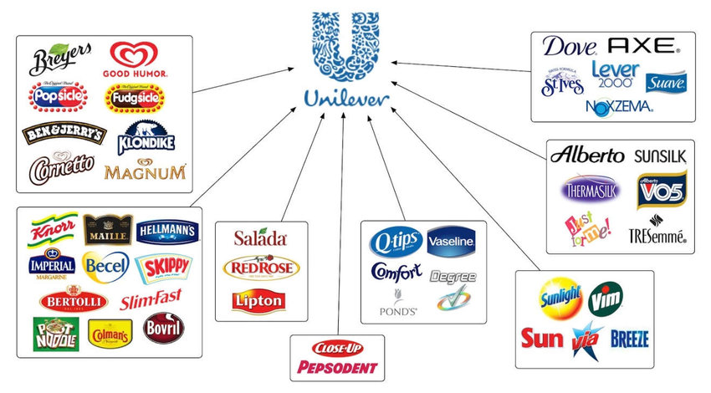

[*Note: Here I include most of the Unilever brand product]*